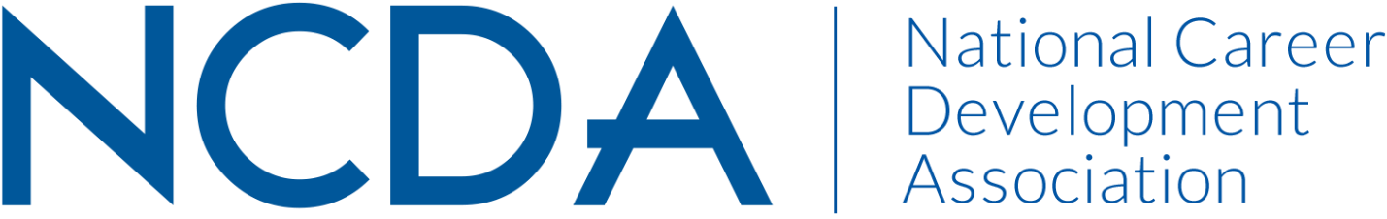

Annual/Mid-Year Report Template

Please prepare your report and submit electronically to dpenn@ncda.org by March 15, 2023, with a copy to your Board Liaison. These reports will be posted on the NCDA Website.

MEMBERSHIP COMMITTEE
MARCH 14, 2023

Committee Co-Chairs:
- Dr. Mary Edwin (edwinmo@umsl.edu)
- Dr. Heather Robertson (robertsh@stjohns.edu)
List Committee Members (no contact information required)
- Amanda G. Schagane (amanda.goldsmith@uky.edu)
- Emily Gomez (egomez@hireheroesusa.org)

Activities to Date
- The committee met on the following dates during the 2022-2023 year: 10/31/2022, 11/16/2022, 03/06/2023; Leadership Meeting (chairs and liaison): 02/06/2023
- Reviewed charges of the newly formed committee; to increase and retain members; articulate value of NCDA to our existing members
- Reviewed data from leadership academy project by G. Nilsson, as well as NCDA membership reports.
- Revised NCDA Membership Committee Description; approved by board 02/2023.
- Created draft of a five-year plan; and set membership goals.
- Conceptualized conference membership drive.

Projected Plan through fiscal year end (September 30th)
Immediate plans between now and September 30th will focus on the membership drive launch at the national conference, including.
- Membership Drive Renewal Discount at Conference
- Membership Drive Table
- Membership Renewal Marketing and Promotion
- Membership Needs and Values Survey

The committee plans to meet at least two more times before the conference to finalize elements of the five-year plan for presentation to the board at the conference.

